Project Design Phase-II
Technology Stack (Architecture & Stack)

Date | 08 October 2026
Team ID | 9100SmartGirls
Project Name | Streamlining IT Procurement: Automating Standard Laptop Orders with Flow Designer
Maximum Marks | 4 Marks

Technical Architecture:
Architecture for the proposed ServiceNow solution: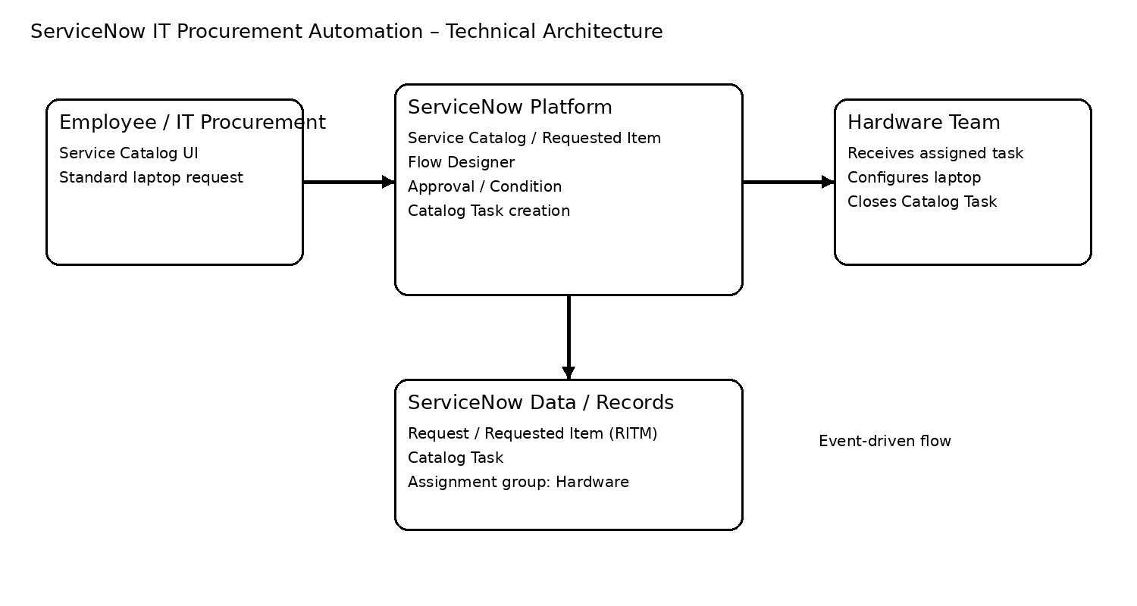
The Deliverable shall include the architectural diagram as below and the information as per the table1 & table 2

Guidelines:
Include all the processes (As an application logic / Technology Block)
Provide infrastructural demarcation (Local / Cloud)
Indicate external interfaces (third party API’s etc.)
Indicate Data Storage components / services
Indicate interface to machine learning models (if applicable)


Table-1 : Components & Technologies:
S.No | Component | Description | Technology
1 | User Interface | Employee/IT procurement user submits a standard laptop request through the Service Catalog. | ServiceNow Service Catalog UI
2 | Application Logic-1 | Starts the automation when the relevant Service Catalog request / Requested Item is submitted. | ServiceNow Flow Designer
3 | Application Logic-2 | Checks the request and approval condition before configuration work is initiated. | ServiceNow Flow Designer conditions
4 | Application Logic-3 | Creates the required configuration task and maps it to the Requested Item. | ServiceNow Catalog Task
5 | Database | Stores request, Requested Item, approval and Catalog Task records used by the workflow. | ServiceNow platform tables
6 | Cloud Database | No separate cloud database is required for this project. | Not applicable – ServiceNow managed data
7 | File Storage | No separate file-storage component is required for the standard laptop workflow. | Not applicable
8 | External API-1 | No external API is required for the proposed automation. | Not applicable
9 | External API-2 | No external API is required for the proposed automation. | Not applicable
10 | Machine Learning Model | No machine-learning model is required; the solution uses rule-based Flow Designer automation. | Not applicable
11 | Infrastructure (Server / Cloud) | The workflow runs on the ServiceNow cloud platform; no separate application server is required. | ServiceNow cloud platform

Table-2: Application Characteristics:
S.No | Characteristics | Description | Technology
1 | Open-Source Frameworks | No separate open-source framework is required for the workflow implementation. | Not applicable
2 | Security Implementations | Uses ServiceNow platform access controls and role-based permissions so only authorized users/teams can work with procurement records and tasks. | ServiceNow roles / ACLs
3 | Scalable Architecture | Event-driven Flow Designer automation avoids manual task creation and can be reused for additional standard catalog items. | ServiceNow Flow Designer
4 | Availability | The solution runs within the ServiceNow platform instead of depending on a locally hosted server. | ServiceNow cloud platform
5 | Performance | The flow is triggered by the request event and performs only the required condition check, task creation and assignment. | Flow Designer

References:
https://c4model.com/
https://developer.ibm.com/patterns/online-order-processing-system-during-pandemic/
https://www.ibm.com/cloud/architecture
https://aws.amazon.com/architecture
https://medium.com/the-internal-startup/how-to-draw-useful-technical-architecture-diagrams-2d20c9fda90d

